Module 4 Assignment: Creating a NoSQL Database in MongoDB Atlas

Name: Sai Mrunaal Chatlapally

Class: 2022Fall-P-IFT458-IFT598-82341-82345

Date: 10-23-2022

**New Node.js project:**

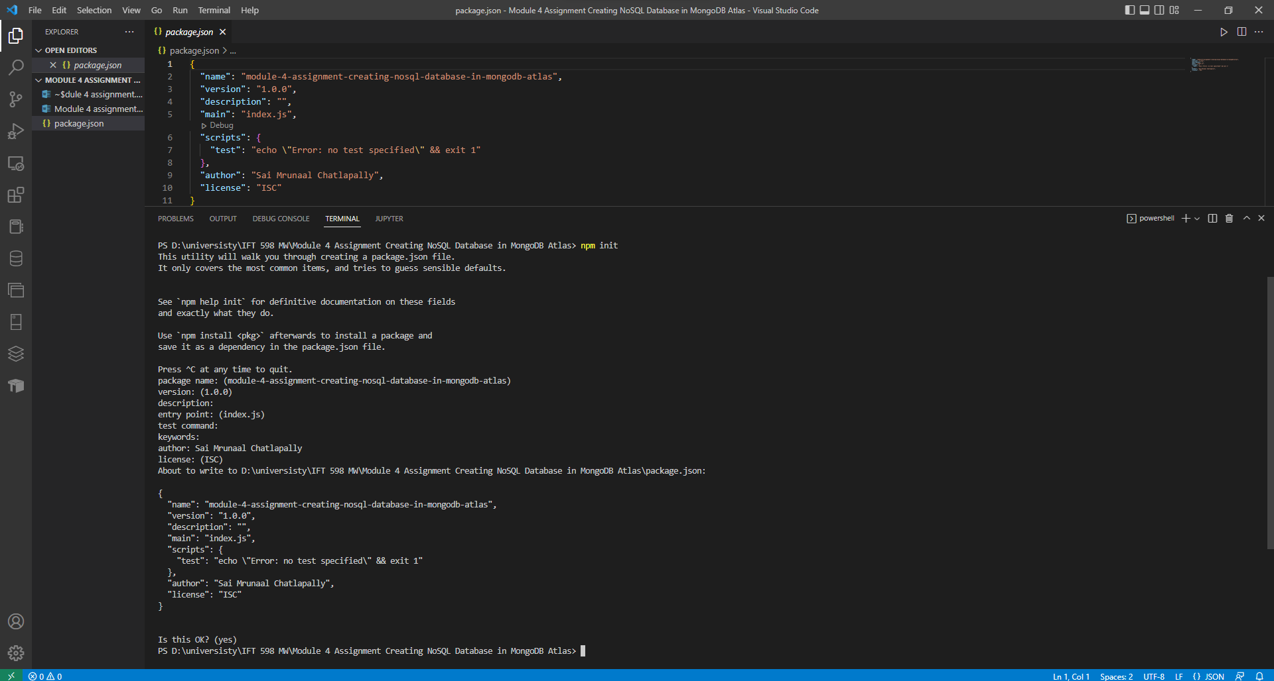

**Step 1: Start by Setting up additional environment variables in "config.env"**

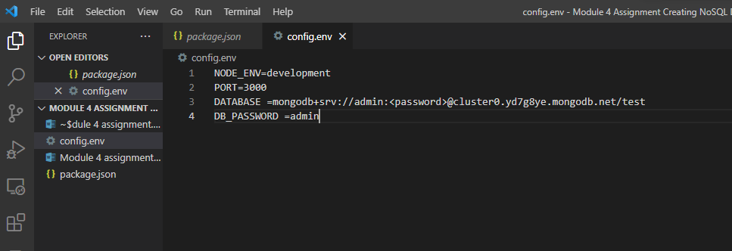

**Step 2: Create the associated files in the correct folder loanRoutes.js, loanController.js and loanModel.js in the model folder.**

loanRoutes:

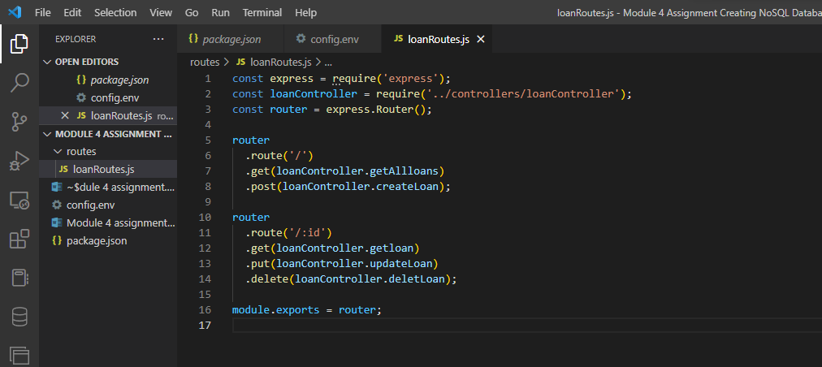

loanModel.js:

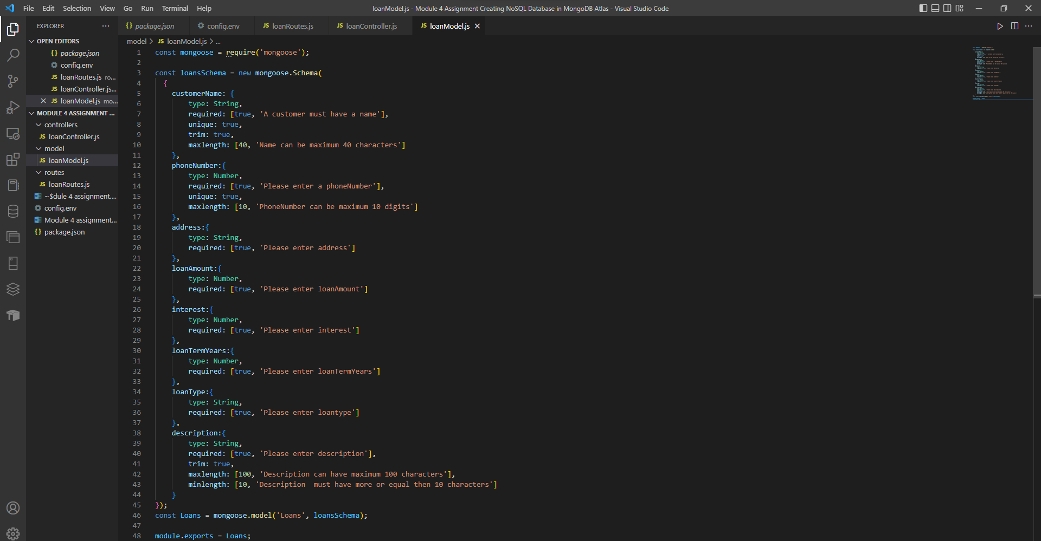

**Step 3: server.js**

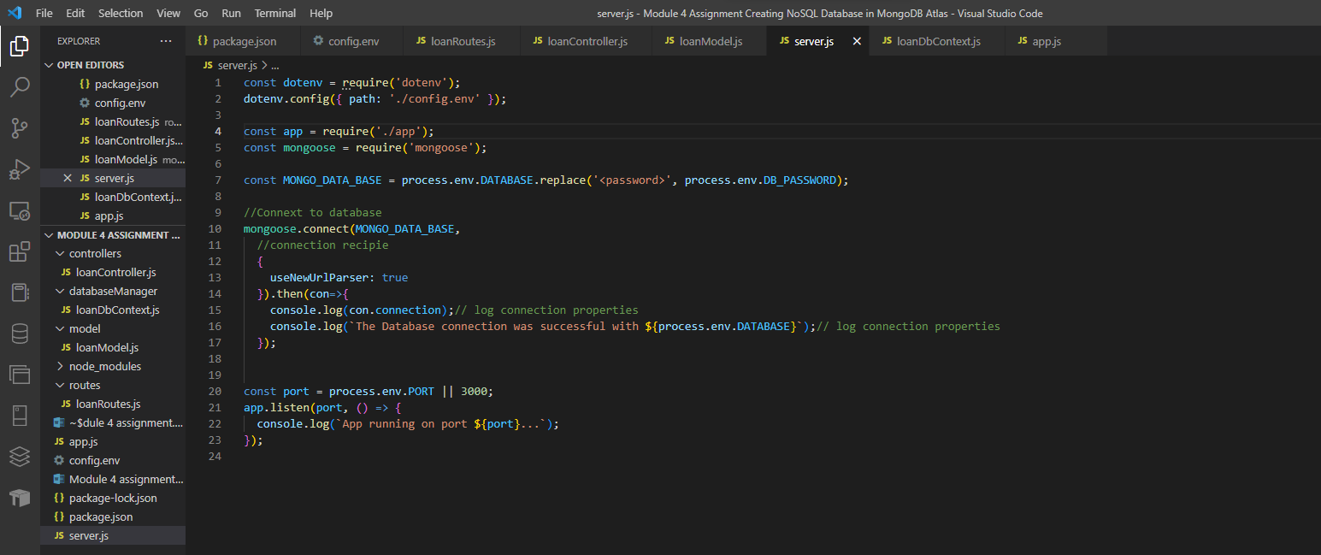

**Step 4: Under folder ”dataBaseManager” create “ "loanDbContext.js”**

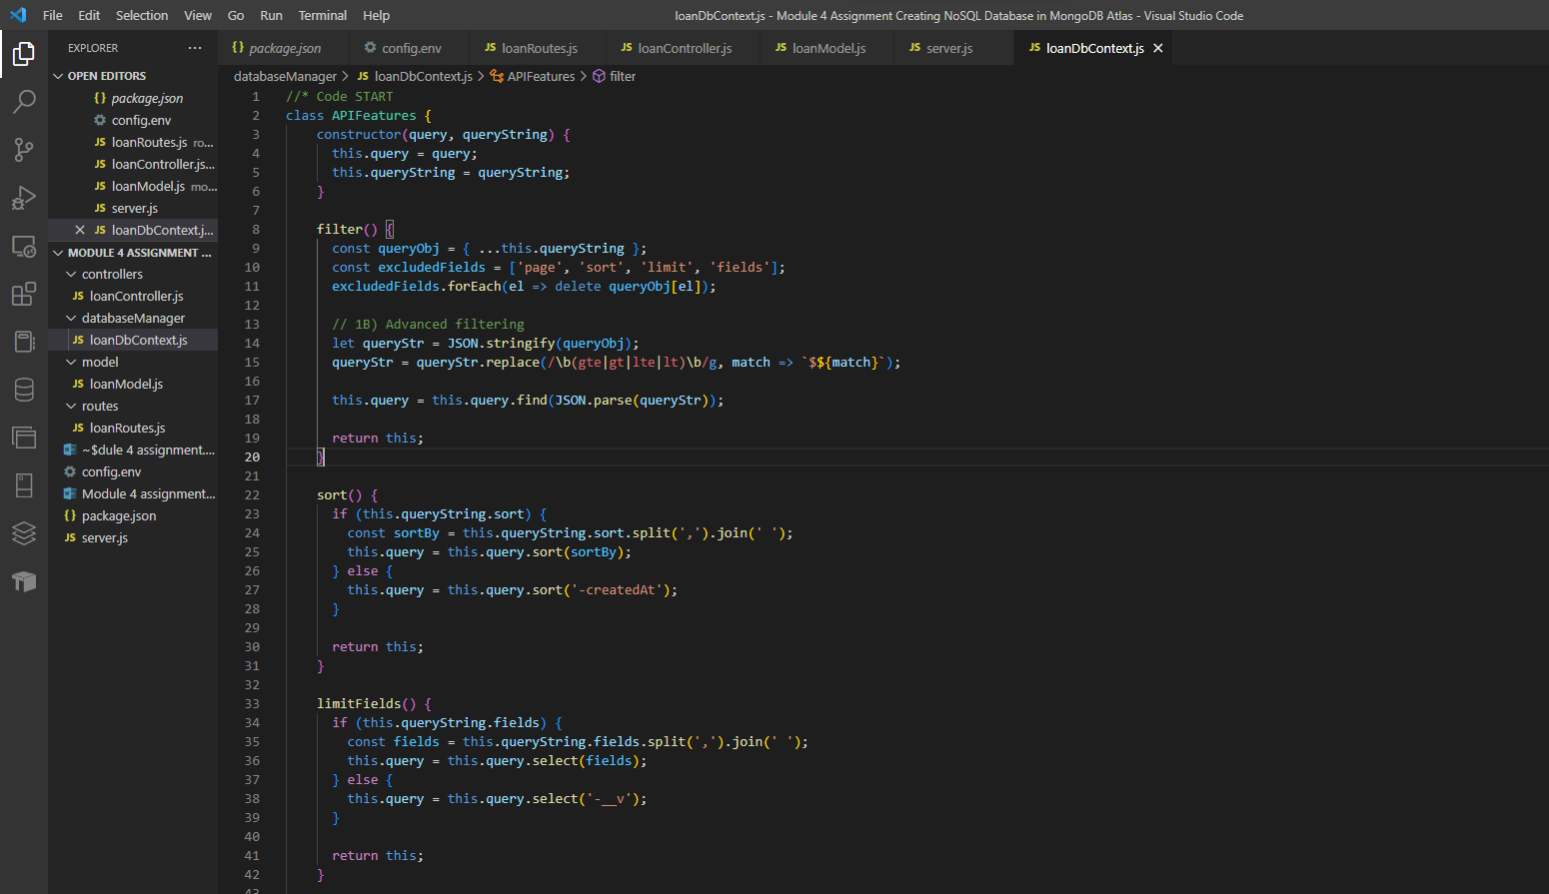

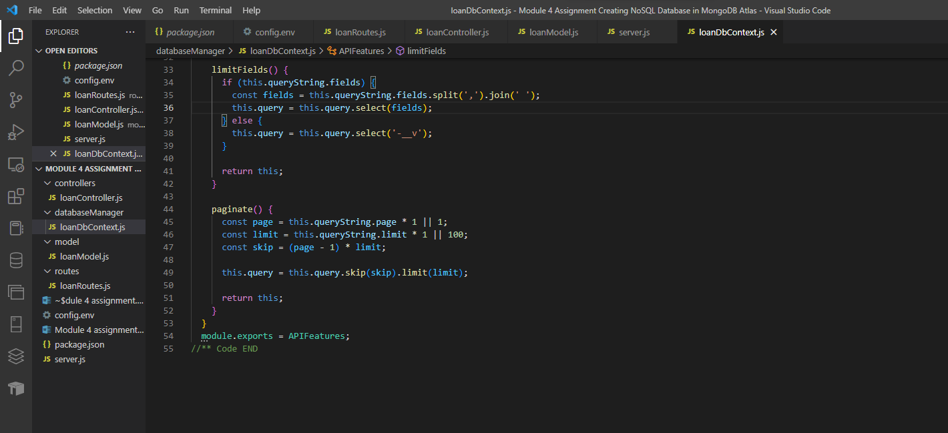

**Step 5: loanController.js**

loanController.js:

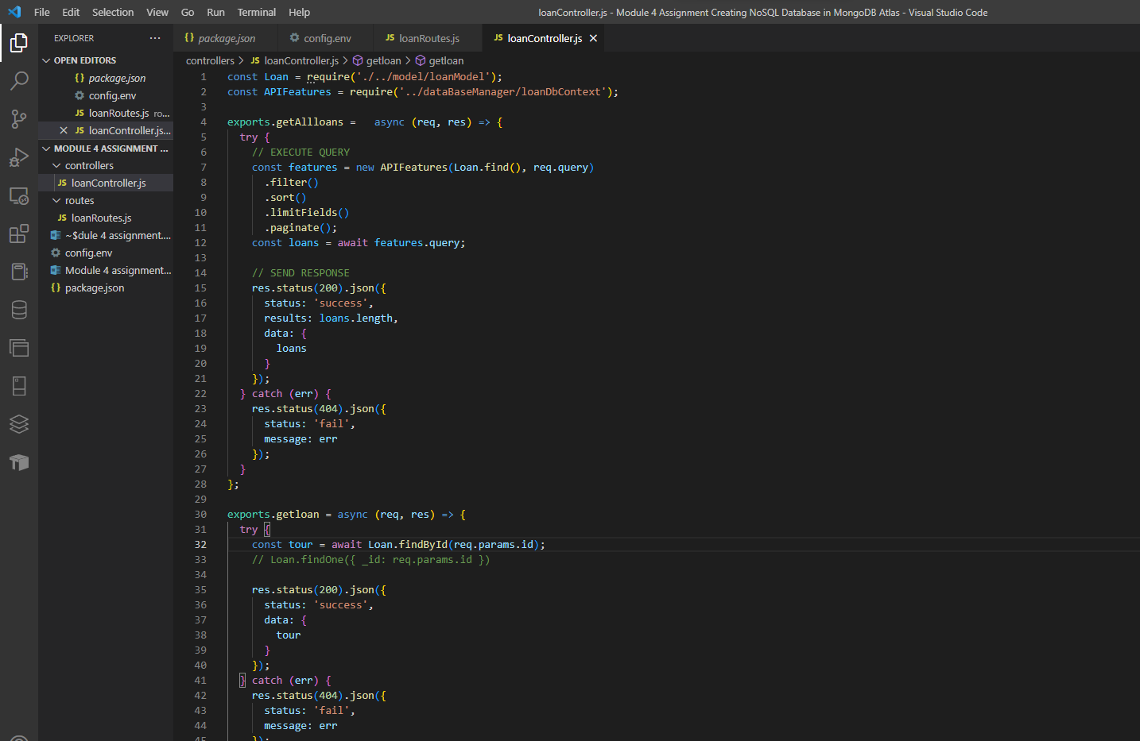

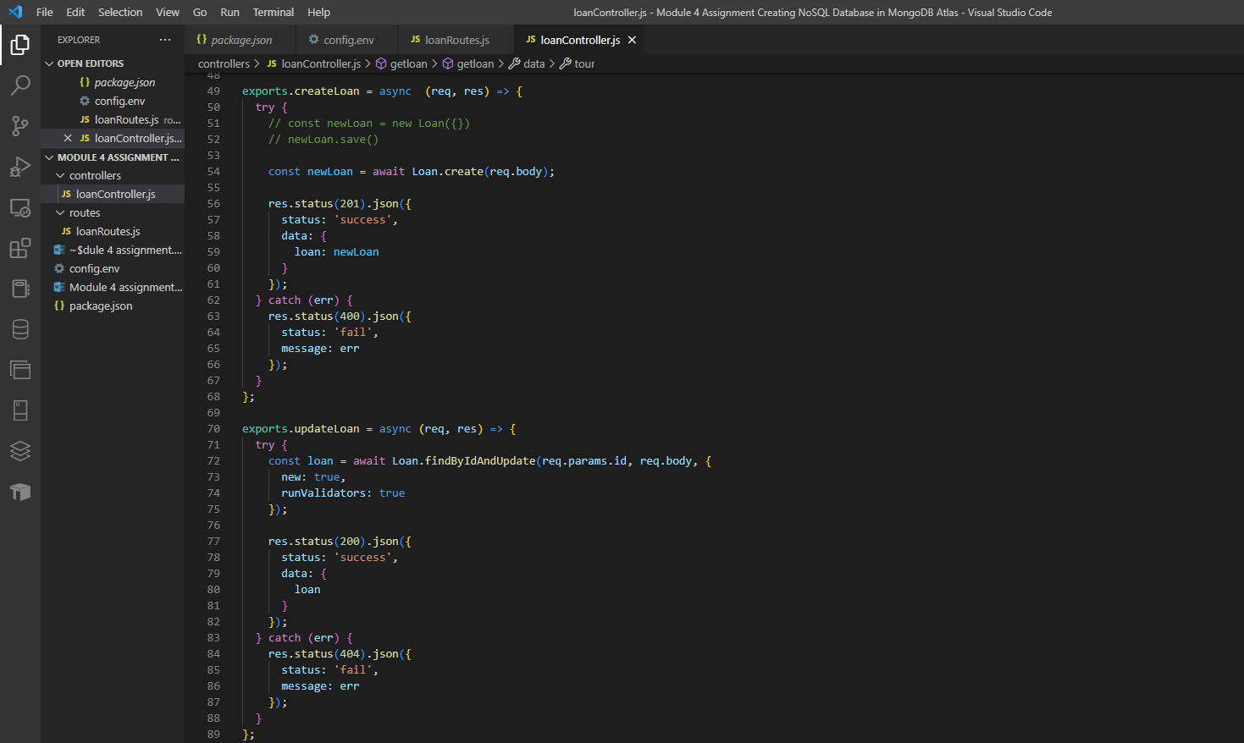

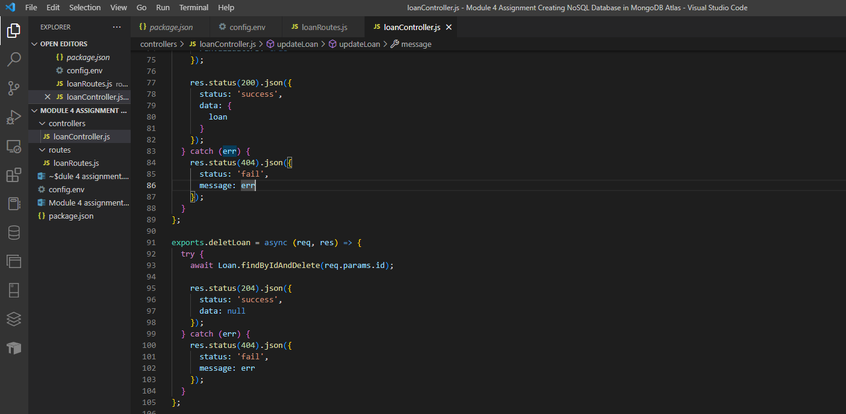

**Step 6: add routes to “app.js”**

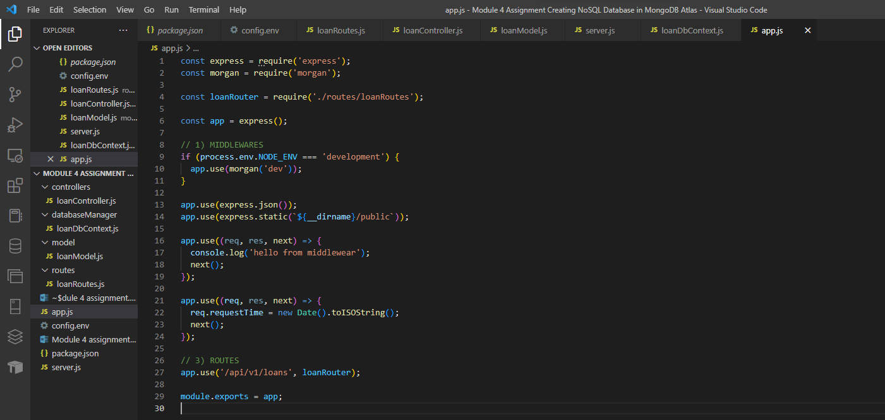

**Executing server.js:**

App running on port 3000

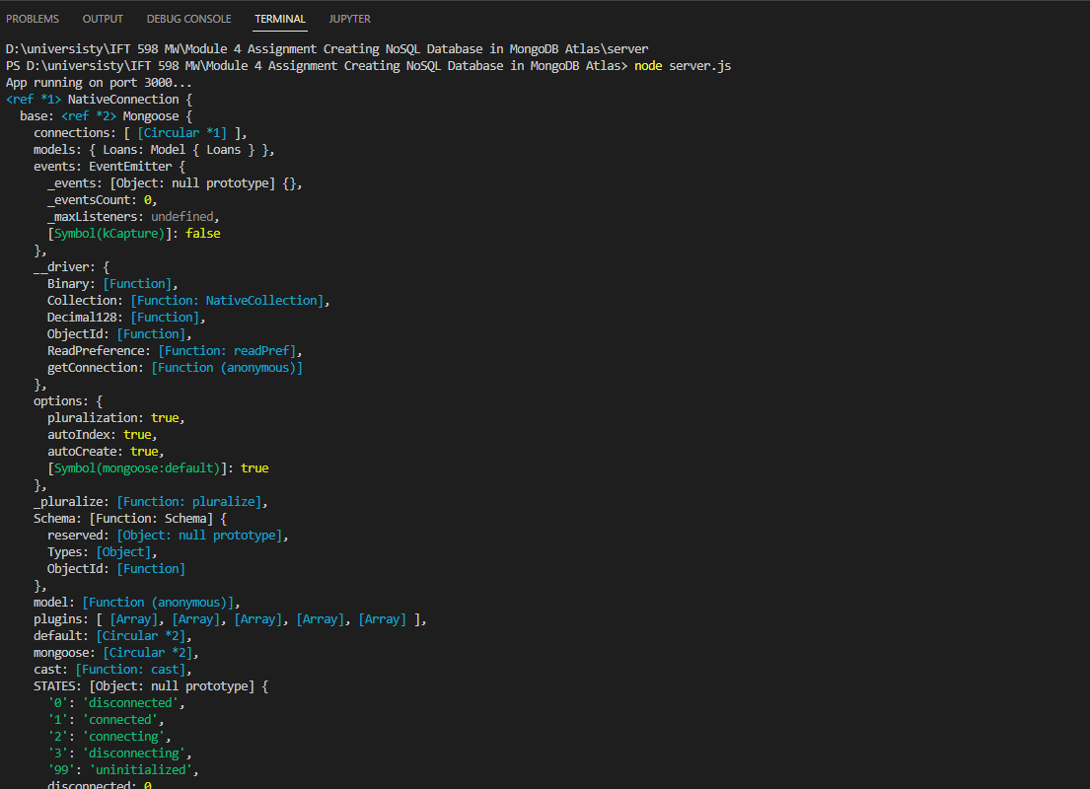

Printing database connection string:

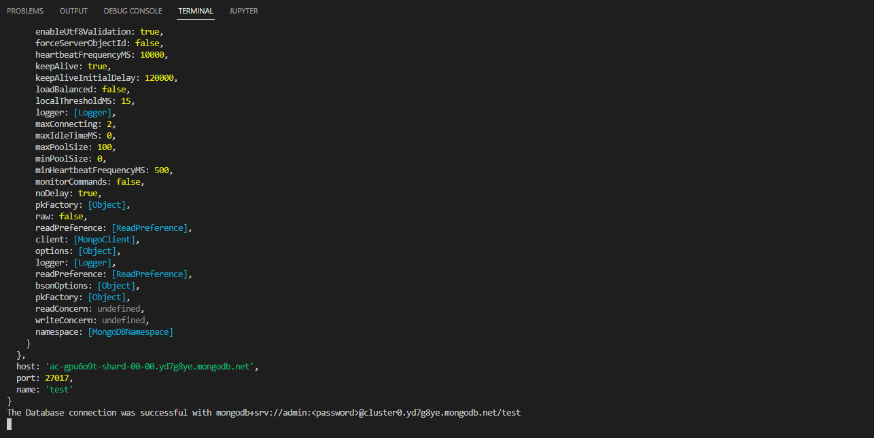

**Adding test loan in postman:**

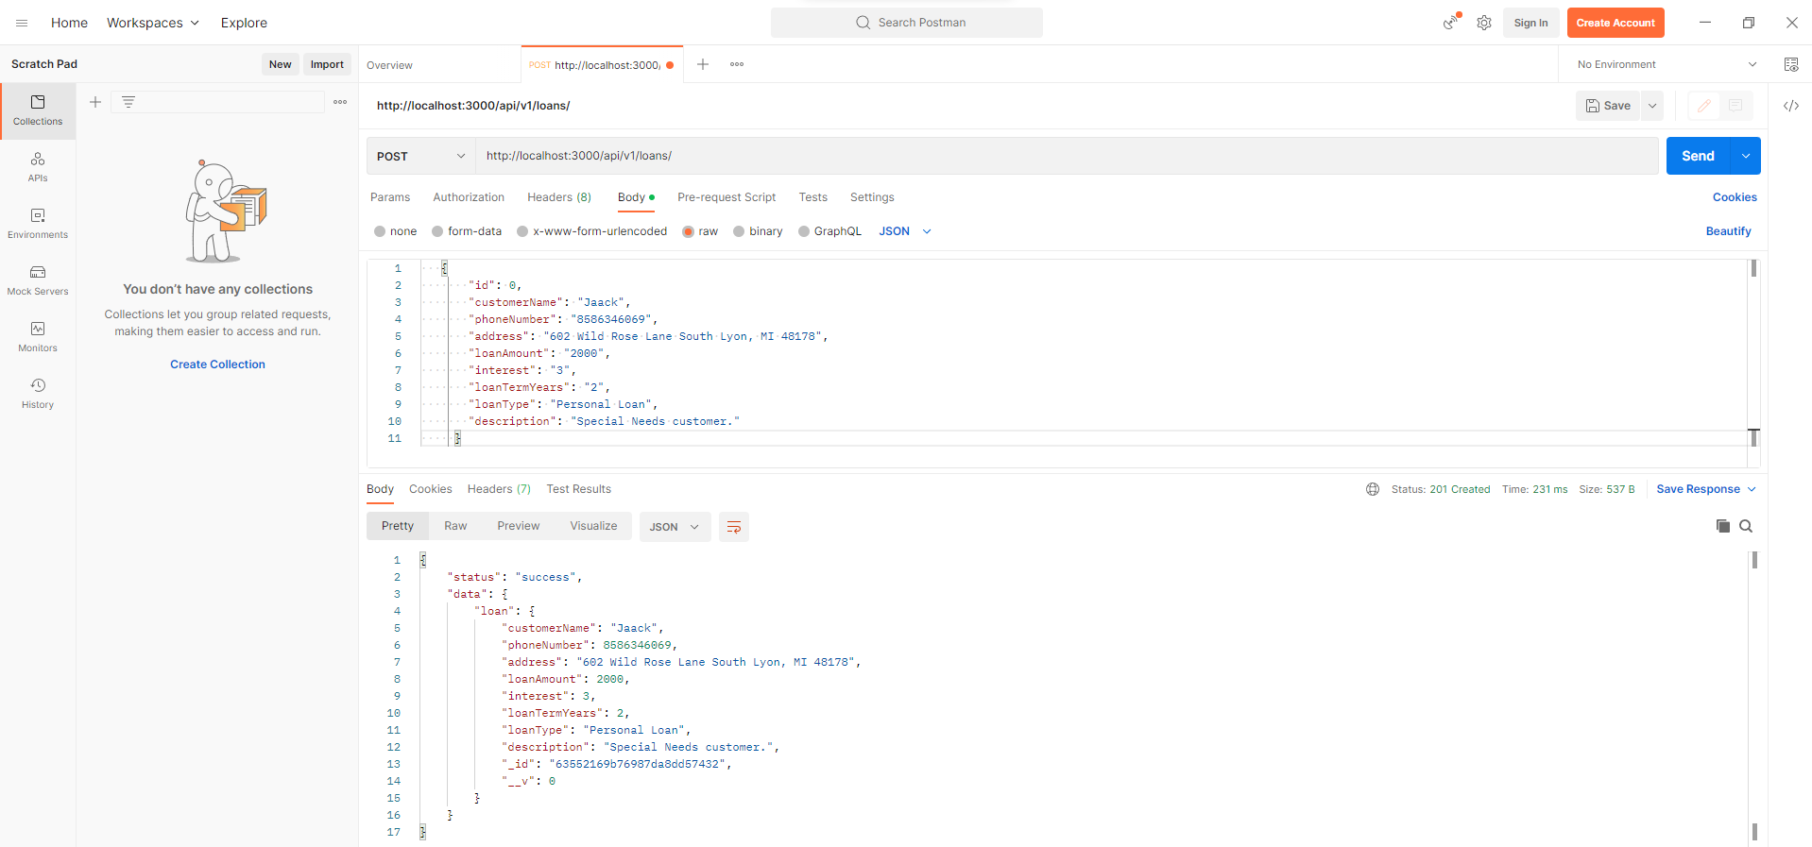

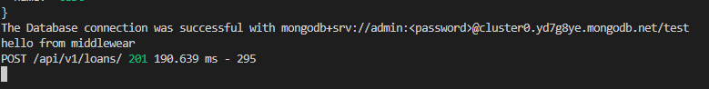

**Adding 5 additional loans (postman):**

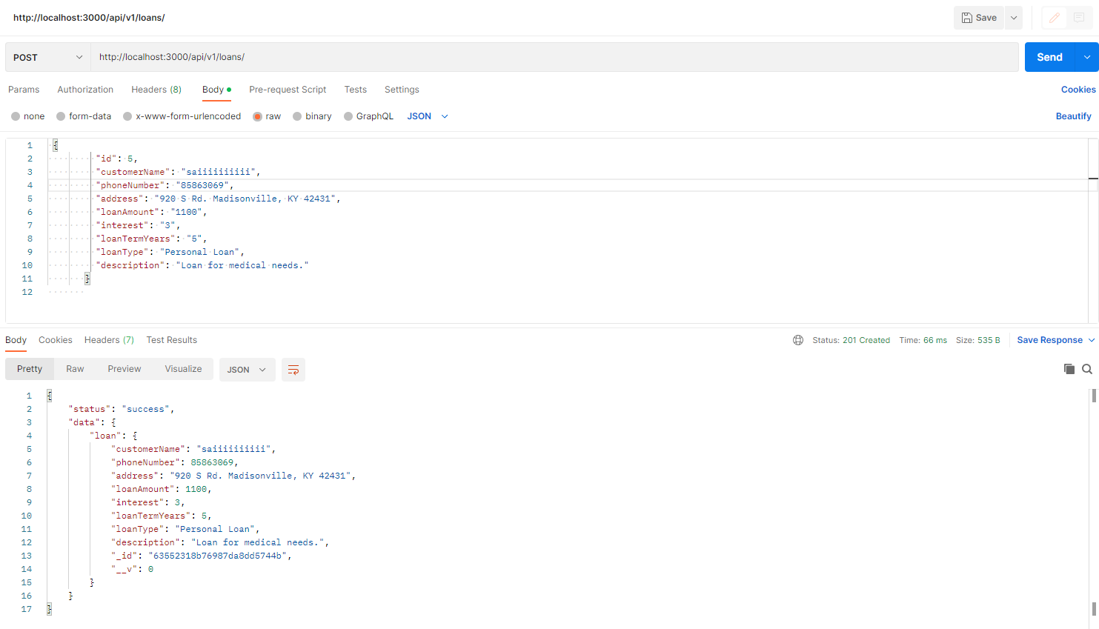

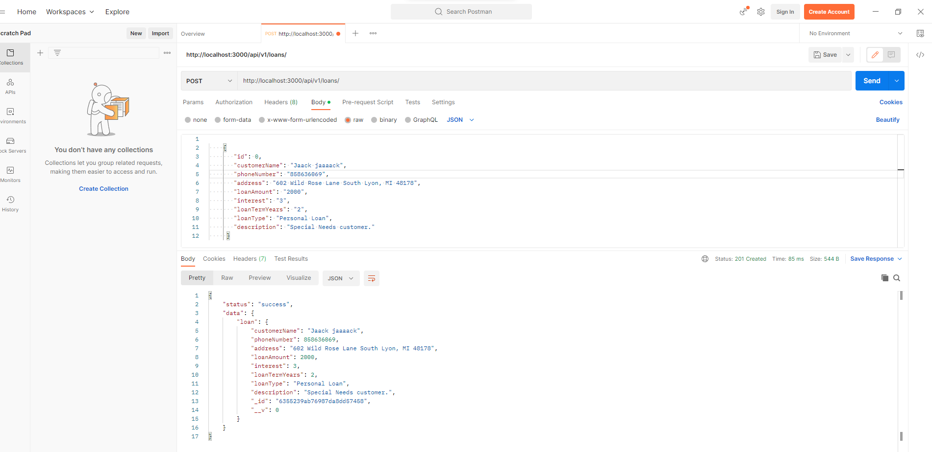

Retrieving all 5 documents posted:

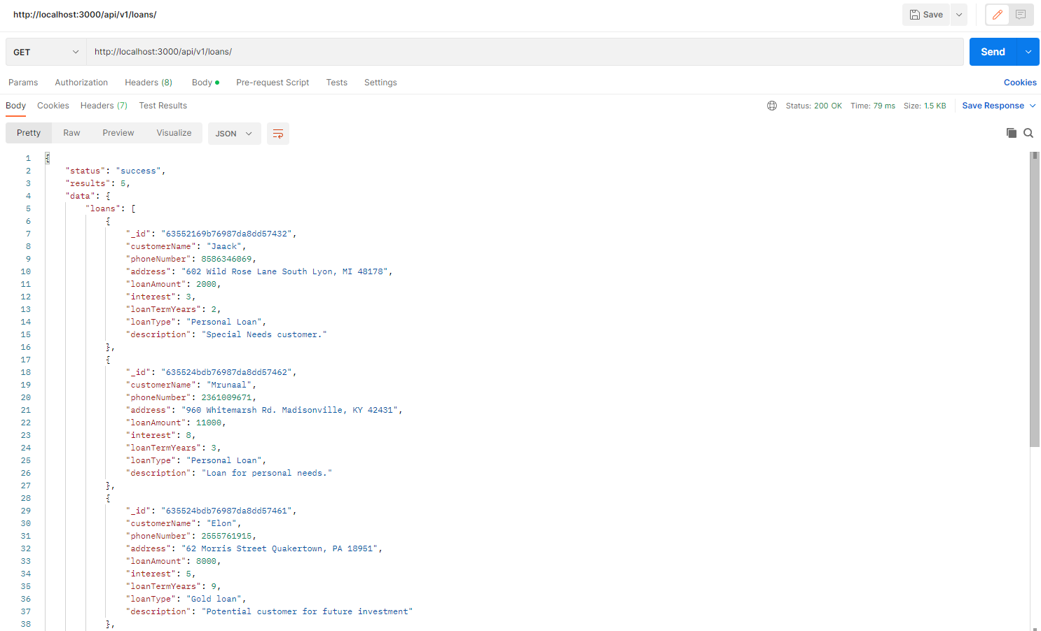

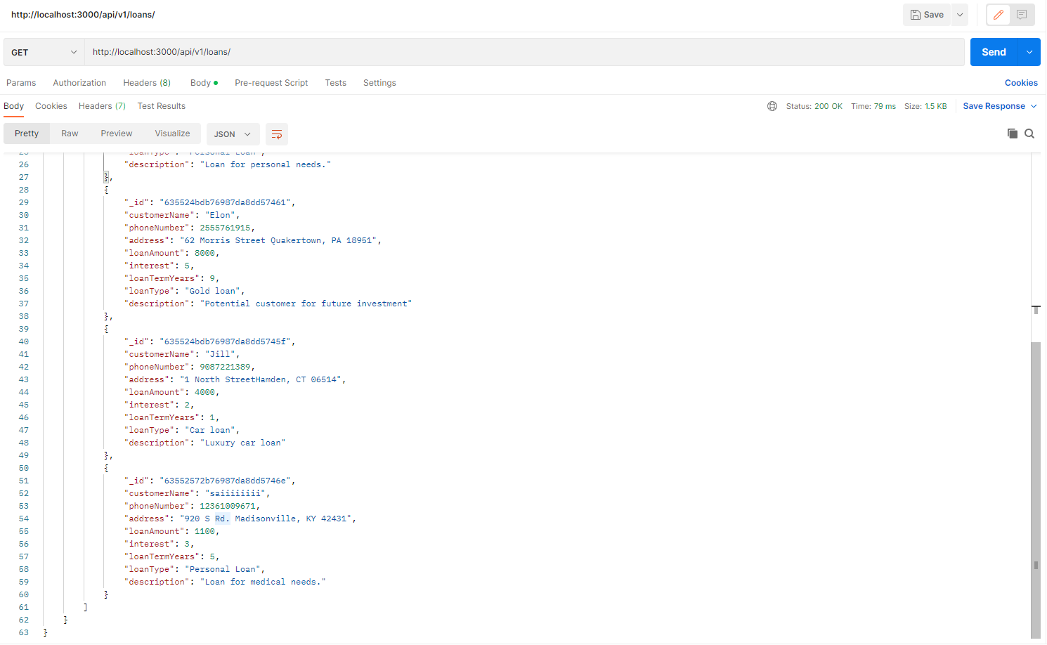

**Get using url:** **http://localhost:3000/api/v1/loans**

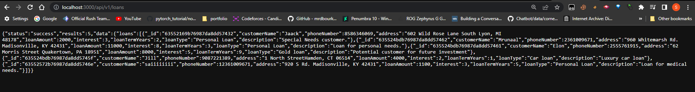

**Updating the value of JSON object using PUT:**

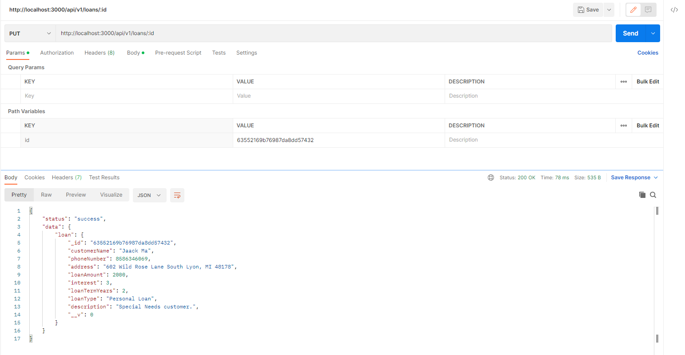

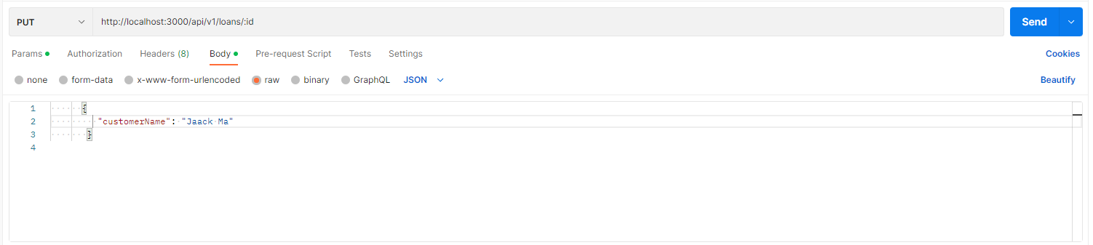

Checking:

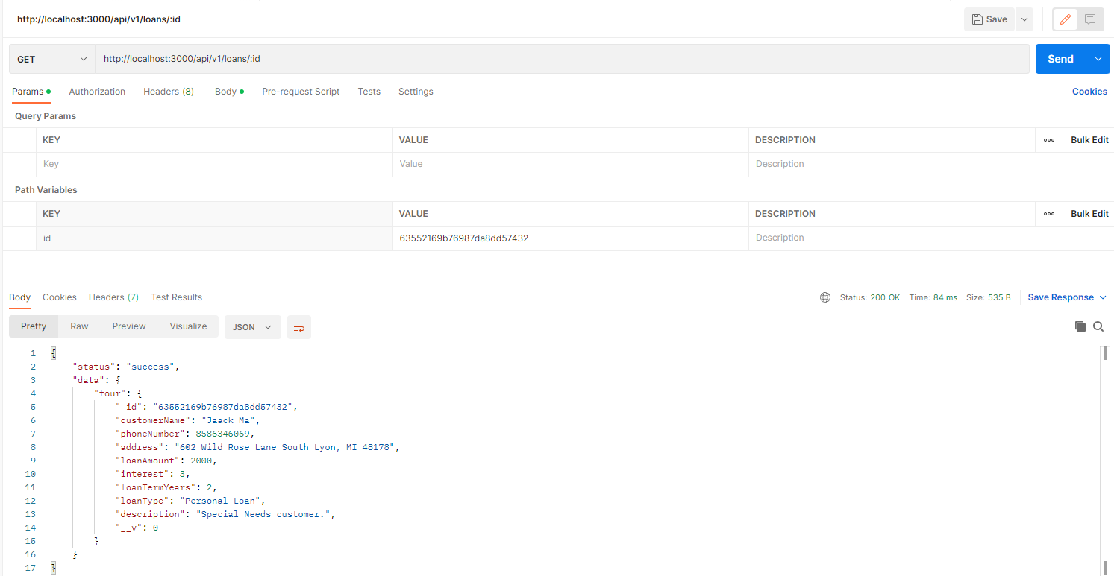

**Delete a user using postman:**



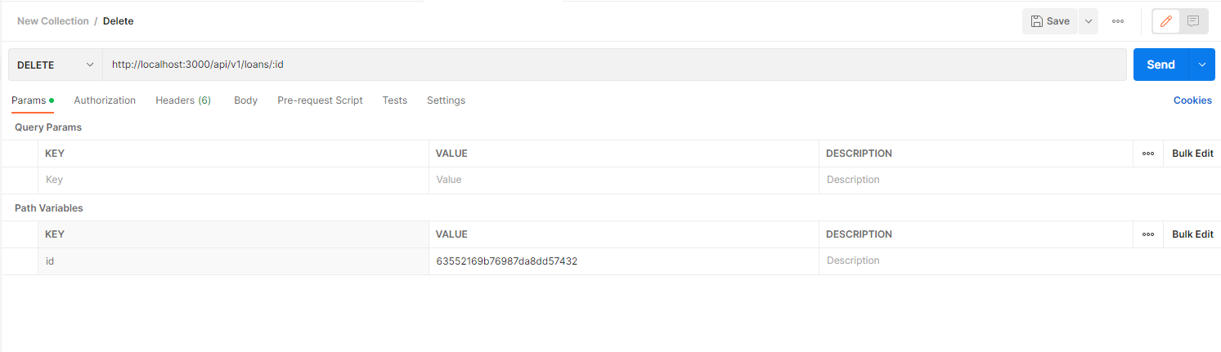

Checking:

We can see all our values are deleted

